Phase 1 — Ideation Phase
Brainstorming, Idea Generation & Prioritization
Field | Value
Date | 31 January 2026
Team ID | SWTID-2026-1543
Project Name | Virtual Agent–Driven SLA Breach Awareness & Justification System
Maximum Marks | 4 Marks

Step 1 — Team Gathering & Problem Selection
The team gathered, reviewed the empathy map insights together, and collaboratively selected the problem statement above as the focus for ideation. A 15-minute silent brainstorming round was used first (to avoid anchoring bias), followed by a group discussion to consolidate and de-duplicate ideas.

Step 2 — Idea Listing & Grouping
Over 20 raw ideas were generated and consolidated into four thematic groups:
- SLA Monitoring & Alerts: Build a Flow Designer engine to track SLA percentages, detect 80%+ thresholds, change incident status to "SLA At Risk", and send automated email alerts to assignees. (Also considered: SMS alerts, Slack/Teams integration — deferred as out of native-platform scope.)
- Virtual Agent Interaction: Design a guided conversation workspace to capture breach reasons and text justifications, allowing users to acknowledge tracking risks directly through chat. (Also considered: voice-based IVR acknowledgement — deferred, low fit for a desk-based agent workflow.)
- Incident Automation & Security: Automate chat updates to push log details to work notes, use UI Policies to mandate fields, and apply ACL security so only assignees can write justifications while others have read-only views. (Also considered: digital signature on justification entries — deferred to a future enhancement.)
- Reporting & Dashboards: Construct centralized analytical widgets to track high-level SLA breach trends and measure overall justification compliance metrics. (Also considered: automated weekly PDF email digest — deferred, dashboard-first approach preferred for real-time visibility.)
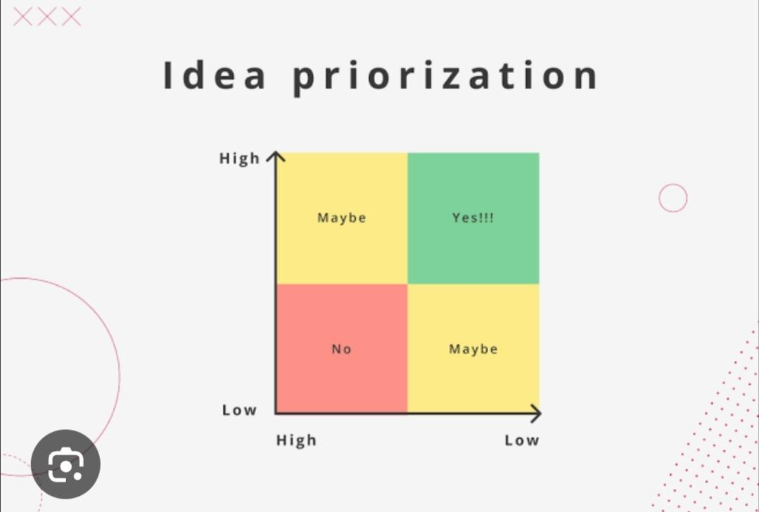
Figure 1.2 — Idea Prioritization Matrix (Impact vs. Effort)

Step 3 — Idea Prioritization
Each idea was scored against three criteria: (1) impact on reducing unexplained SLA breaches, (2) feasibility as a zero-code, native ServiceNow build, and (3) implementation effort within the available sprint capacity. Ideas landing in the "Yes!!!" (high-impact, low-effort) quadrant were prioritized first.
- High Priority (Core Scope): Flow Designer monitoring engine, automated email alerts at the 80% threshold, mandatory UI Policy form fields, and assignee-only ACL security restrictions.
- Medium Priority (Conversational Scope): Virtual Agent guided interaction tree, automated work-notes logging, and executive trend dashboards.
- Low Priority / Deferred: AI breach time-prediction models, SMS/third-party chat integrations, and digital-signature justification — deferred to keep the delivered solution a zero-code platform framework within scope and timeline.

Outcome
The prioritized ideas were consolidated into the four solution pillars carried into the Requirement Analysis and Project Design phases: Automated Risk Detection, Conversational Governance, Access Control, and Real-Time Reporting.

